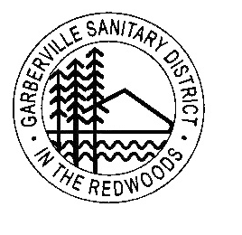
Garberville Sanitary District
PO Box 211
919 Redwood Dr.
Garberville, CA. 95542
Office(707)923-9566 Fax(707)923-3130

2026
BOARD CALENDAR

JANUARY 27th—BOARD MEETING

FEBRUARY 24TH--BOARD MEETING

MARCH 24th—BOARD MEETING

APRIL 22nd—PLANNING-TRAINING MEETING

APRIL 28th—BOARD MEETING

MAY 19th—BOARD MEETING (Memorial day 25th)

JUNE 23rd—BOARD MEETING

JULY 28th—BOARD MEETING

AUGUST 25TH—BOARD MEETING

SEPTEMBER 22nd—BOARD MEETING

OCTOBER 27th—BOARD MEETING

NOVEMBER 17TH—BOARD MEETING (Thanksgiving 26th)

DECEMBER 15TH—BOARD MEETING (Christmas 25th)

