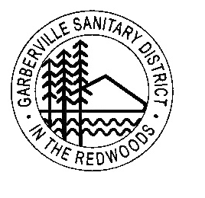
Garberville Sanitary District
PO Box 211
919 Redwood DR.
Garberville, CA. 95542
Office (707)923-9566 Fax (707)923-3130

Sec 14.1 Pools and Tanks. When an abnormally large quantity of water is desired for filling a swimming pool or other purposes, arrangements must be made with the District prior to taking such water. Permission to take water in unusual quantities will be given only if it can be safely delivered through the District’s facilities and if other consumers are not inconvenienced thereby. A copy of procedures will be given along with permission.

- Any person wanting to fill a pool or large tank must fill out an application at the District Office, so water quantity can be monitored and fill rate can be determined.
- Pools and Tanks can ONLY be filled when the River Level is above 30 CFS and approved by General Manager or designee.
- Pool and Tank fill rate will be $5/unit of water (748 gallons per unit of water).

Sec 15.7 Fee for Filling Pools. Any person wanting to fill a swimming pool, must fill out an application at the GSD Office (no cost). This application will be on file with customer account and used to verify the gallons required.
        - Fee for filling pools will be less than regular potable water use and based on gallons used.
        - The fee is calculated by units of water used (748 gallons = 1 unit).
        - The units of water will be billed at $5/unit of water used to fill pool or tank.

